**Assignment -4**

Digital Marketing

|  |  |
| --- | --- |
| Student Name | Vigneshwarakarthick M |
| Student Register Number | 953720106033 |
| College Name | AAA College of Engineering and Technology |

**QUESTION:**

**SOCIAL MEDIA NEWSLETTER USING CANVA:**

**Poster link:**

[**https://www.canva.com/design/DAFtMHwo0Vg/XHCDU3YWf3URAkF-KkEI5Q/edit?utm_content=DAFtMHwo0Vg&utm_campaign=designshare&utm_medium=link2&utm_source=sharebutton**](https://www.canva.com/design/DAFtMHwo0Vg/XHCDU3YWf3URAkF-KkEI5Q/edit?utm_content=DAFtMHwo0Vg&utm_campaign=designshare&utm_medium=link2&utm_source=sharebutton)

**Poster Title: Naveen Coffee Shop**

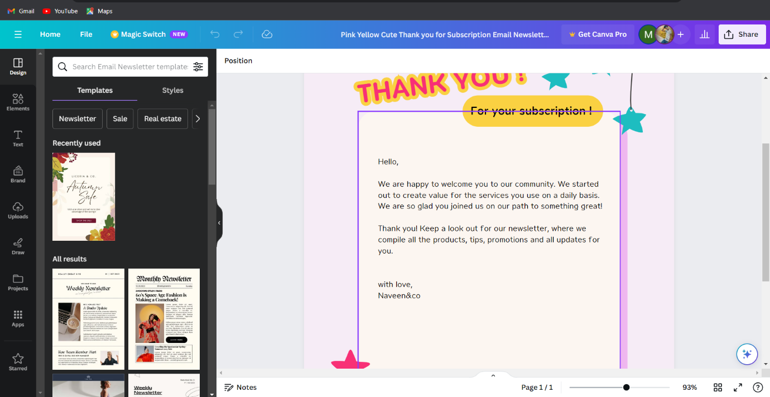

**Poster:**

